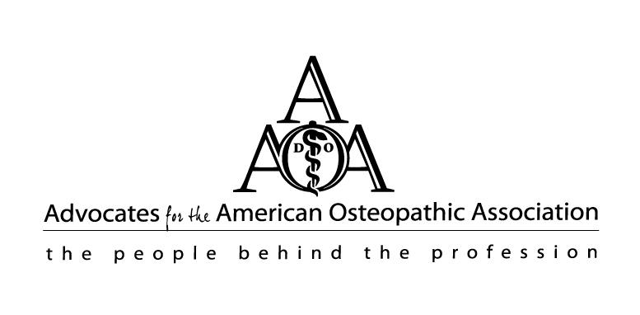
2022 Advocates for the AOA CANDIDATE APPLICATION
Email completed application to advocates@osteopathic.org on or before August 1, 2022.

This application is to be completed by the candidate personally and submitted prior to the above deadline by email. Receipt for this application will be sent by email from the AAOA Affiliate Director advocates@osteopathic.org and from the Chairman of the 2022 Nominating Committee, Caryn Tabby, caryn.tabby@gmail.com.
The positions to be filled for the 2022-2023 AAOA Board of Directors are as follows:
President-Elect
Vice President
Recording Secretary/Treasurer
Director (2 year position) term ending 2024

Director (2 year position) term ending 2024

A candidate for elective office shall meet the following qualifications:
- A member in good standing for at least one year.
2. A candidate for the office of President-Elect or Vice President shall have served on the AAOA Board of Directors for at least two years.

3. Further information on specific duties may be found in the AAOA Bylaws.

Any interested persons should submit a completed application to the Nominating Committee before August 1, 2022.
Submission of an application does not guarantee a position on the board. Applications will be reviewed by the nominating committee who will then present a slate of nominees at the Annual Business Meeting of the Advocates
for the American Osteopathic Association. The slate will also be posted in advance on the AAOA website.
Nominations will be accepted from the floor during the annual business meeting of the AAOA.

Those wishing to encourage participation of other individuals should

pursue this prior to the August 1, 2022 deadline period.

NAME OF CANDIDATE:
HOME ADDRESS:

TELEPHONE CONTACT - Home #: Cell#
EMAIL ADDRESS:
Please consider my application as a candidate for the following position(s) on the AAOA Board of Directors:
☐President Elect ☐ Vice President ☐Recording Secretary/Treasurer ☐Director (two-year term)

☐ I am currently serving on the AAOA Board of Directors.

☐ I am a member in good standing for the current membership year beginning June 1, 2016, as:
☐Regular ☐Retired ☐Widowed ☐IRAA ☐SAA ☐Life

☐ I have been a member in good standing for at least two years prior to the current membership year as:
☐Regular ☐Retired ☐Widowed ☐IRAA ☐SAA ☐Life

☐ I have completed two years on the AAOA board previously and am applying for a current position. (Please list the membership years of your prior terms on the board, noting in what capacity you served, (e.g., Director or Officer position.)

OSTEOPATHIC PERSONAL CONNECTIONS Membership in the Advocates for the American Osteopathic Association is open to all. What is your connection(s) to the Osteopathic Family? Provide what you feel is helpful for understanding your level of interest, support and commitment to the osteopathic profession below:

☐I currently live in a state with no state affiliated organization of AAOA.

☐ I am now or was previously a member in good standing of an Intern/Resident affiliated organization of AAOA.
Area/Name of Organization:
Contact information:
☐I am now or was previously a member in good standing of an SAA affiliation organization of AAOA.
Area/Name of Organization:
Contact information:
☐I have more than one active membership with an AAOA affiliate. Please list other affiliate organizations:
Area/Name of Organization:
Contact information:

Osteopathic Connections:
☐ I am the spouse of an osteopathic physician, or
☐ I am the significant other of an osteopathic physician.
Name of D.O.:
☐I am an osteopathic physician. School of graduation:
☐ Other affiliation:
LEADERSHIP EXPERIENCE (Osteopathic Advocate/Auxiliary Participation)
Please tell the Nominating Committee about your leadership experience by completing the following as applicable to national, state, IRAA or SAA. Indicate the choice and please provide details (CV/Resume may be attached instead).

CURRENT OFFICE(s) HELD: ☐National ☐State ☐IRAA ☐SAA
Title: Organization:
How many years did you serve in this position?
Describe any specific duties or activities while serving in this capacity:

COMMITTEE (s) CHAIRED: ☐National ☐State ☐IRAA ☐SAA
Title: Committee Name:
Chapter Name:
How many people were on your committee?
How many years did you serve as chairperson of this committee?

COMMITTEE MEMBER PARTICIPATION: ☐National ☐State ☐IRAA ☐SAA
Committee Name:
Chairman of Committee:
How many years did you serve as member of this committee?
As a member of this committee, what was your responsibility?

CURRENT OFFICE(s) HELD: ☐National ☐State ☐IRAA ☐SAA
Title: Organization:
How many years have you served in this position?
Describe your duties or activities while serving in this capacity:

PREVIOUS OFFICE(s) HELD: ☐National ☐State ☐IRAA ☐SAA
Title: Organization:
How many years did you serve in this position?
Describe any specific duties or activities while serving in this capacity:

What do you feel you could contribute as a member of the AAOA Board?

PERSONAL BACKGROUND
Please tell the Nominating Committee about yourself (Extra pages, a CV, or a resume may be attached or used to replace this section)
- Please share your education or training background. Name of college and degree(s) if obtained:

- Are you presently employed full or part time, if so, what is the job and position you hold?

- Other pertinent information that you would like the Nominating Committee to consider: (awards, special recognition, honors, etc.)?

- If you are active in volunteer work in any areas, please share what you do and for whom:

- Skills or experience in business, financial management, promotions, marketing, event planning, education and website development are all areas of need for the AAOA:

- Please share any special skills, talents or interests:

If the Nominating Committee wishes to clarify information in this form, which is your preferred time and means of
contact from the information provided in this form?

☐Home phone ☐Cell Phone ☐Email

☐8-12 mornings ☐12-5 afternoon ☐5-9 evening ☐Other

AAOA BOARD OF DIRECTOR RESPONSIBILITIES
By submitting this application as a candidate for the positions marked, I acknowledge that members of the AAOA board are expected to attend Post-Convention, Mid-Year, Pre-convention Board Meetings and conference calls throughout the year. I have read and accept the following regarding my potential board participation.

According to the bylaws lasted revied 2020, members of the AAOA Executive Committee are expected to chair specific committees. These responsibilities are as follows:

- President Elect shall serve as the chairperson of the Student Advocates Association (SAA) Committee.
- Vice President shall serve as the chairperson of the Membership Committee.
- Secretary/Treasurer shall serve as the chairperson of the “A.T. Still Fit for Life” Fun Run Committee.

All other committee chairs are appointed by the President. Other committees include (but are not limited to):
Convention, Intern Resident Advocate Association (IRAA), Special Projects, Publicity and Website, Educational
Endowment Fund (EEF), Legislative Awareness, and Yellow Ribbon Suicide Prevention. Members of the Advocates for the American Osteopathic Association Board of Directors are expected to chair a committee, are responsible for the success of that committee, and expected to reply to electronic correspondence (email) and present committee reports.

CANDIDATE’S WRITTEN CONSENT

I hereby give consent to have my name placed in nomination for the AAOA position for the 2022 year as indicated herein. The information is provided solely by me and is submitted in this email. I have provided confirmation that I meet the qualifications for the positions desired and if elected, will fulfill the duties of my position and will uphold the mission of the AAOA to the best of my ability.

(Electronic Signature) (Date)

